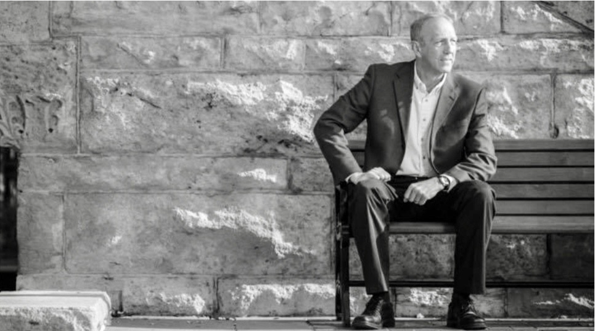

Conductor on the Wabash:
One last reflection on Greg McHenry, Riley County Appraiser, AAS, RMA; Past IAAO President
By Heather Poore, Rooks County, Co-Editor

The Wabash Cannonball, known as the Kansas State Wildcat’s second fight song, is a song that is historical, made up by hobos back in the late 1890’s. This American folk song’s rhythm was steeped in the sound of the train tracks and softened by the beauty of the country that the many trains that ran through the Midwest were privy to during the golden age of railroad. The song itself was the only piece of sheet music to survive KSU’s Nichols Hall fire in 1968 and the band’s director thought it a sign that it should be played.

Why all this history on the Wabash? A former Kansas State Alumni recently lost his fight to cancer at the end of February. And appropriately, that was the last song played at Greg McHenry’s funeral on March 11.

Greg McHenry served as Riley County’s appraiser for the last 30 years. Like the Wabash Cannonball, McHenry was known for his welcoming demeanor and quick smile. He started this career by accident like most appraisers, just applying for a temporary reappraisal job when his position was being eliminated due to budget cuts. With his background on the farm, the ag delineation job at Riley County seemed like the perfect in-between job. However, McHenry found the work not only suited him, but he had a unique ability to connect with people.

This understanding of relationships led to McHenry speaking at community groups, on
the radio and anywhere that would allow him to speak about appraisals and how the taxation system worked in Riley County. This led to stronger community partnerships, which was good, but not quite enough to win over the hearts and minds of property owners. Then an idea was born. He and Riley County appraisal analyst Allen Todd hired 502 Media to make a short video explaining how a tax bill is created and how the appraiser’s office fits into that equation. At the beginning of the campaign, informal appeals dropped 40% and the relationship with the community improved even more. The success was not just limited to Riley County; over 100 other jurisdictions have tailored the video to promote their offices. Additional videos were added in Riley County after this success, with future property owners as the target group.

“Life is too short to waste on worrying or stressing. Just do your honest best in all that you do and let God take care of the rest.”

This leadership to reach out extended into positions within the Kansas County Appraisers Association and the International Association of Assessing Officers. McHenry served as president of the KCAA and was a mentor with the Kansas City IAAO regional chapter. He was voted to represent Region 1 on the IAAO Board of Directors in 2015-2017. McHenry went on to be elected as vice president in 2018 and just finished his term as IAAO president in 2021. There were numerous committees he served on, from the KCAA legislative committee to the IAAO Hagemann Trust committee. McHenry was extremely grateful for his amazing team at Riley County, KCAA and IAAO. All three of these groups placed high value on education and informed decisions, something McHenry himself valued.

He was not a man that would sweat the small stuff. “Life is too short to waste on worrying or stressing,” McHenry said in a past article that appeared in Appraising the Plains. “Just do your honest best in all that you do and let God take care of the rest.”
The guy with an easy smile that never seemed to let the pain of his five-year battle touch him. He just kept chugging along until he finally came to his last stop on his life’s train route. The last lines of the Wabash Cannonball are a fitting tribute to McHenry, who wanted Every Man A Wildcat. The last stanza of the Wabash was tailored just for Greg McHenry by his pastor Brian Smith.

Now here’s to Greg McHenry, may his name forever stand
And always be remembered by those throughout the land
His earthly days are over and the purple curtains fall
We’ll carry him home to victory on the Wabash Cannonball.

